**Fall Semester 2021-2022**

**Review-lll**

**Cloud Computing**

**Topic:**

Hospital Management System

**Team Members:**

Jashwanth Kumar S-20BCS0139

Raghul D-20BCS0140

Jerin Jebaraj J-20BCS0152

**Table of Contents:**

* Introduction
* Front End
* Back End
* Code
* Screenshot
* Link of our project

**Introduction:**

Hospital Management System is a system enabling hospitals to manage information and data related to all aspects of healthcare – processes, providers, patients, and more, which in turn ensures that processes are completed swiftly and effectively. When one thinks of the various aspects and departments of a hospital, it becomes apparent that an HMS is critical. The hospital database management system was introduced in 1960, and has greatly evolved since then – with the ability to integrate with the existing facilities, technologies, software, and systems of a hospital. Today, patients can begin the process of healthcare in the palm of their hand – the mobile devices and apps – make this possible. This process then moves to the healthcare providers and hospitals.

**Front End:**

In our project, we use to create a website by using like html ,css and javascript.

**Html:**

* The Body
* HyperText Markup Language (HTML)
* Content and basic structure
* Describes and defines
* Made up of tags
* Tells the browser what to display

**Css:**

* The Accessories
* Cascading Style Sheet (CSS)
* Gives style and structure to the content
* Link the CSS file to the HTML
* Tells the browser how to display

**JavaScript:**

* The body’s ability to perform actions
* JavaScript is not Java
* Behaviour of the website
* Used for interactive functionality
* Allows for the user to interact with the browser

**Back End:**

* we use backend for our project is php,SQL queries
* In php we use like $symbol like only use for normal variable (int,float,double),echo(construction statement),
* In SQL we use like select ,update ,groupby,orderby ,where condition.

**Code:**

<?php

include_once('hms/include/config.php');

if(isset($_POST['submit']))

{

$name=$_POST['fullname'];

$email=$_POST['emailid'];

$mobileno=$_POST['mobileno'];

$dscrption=$_POST['description'];

$query=mysqli_query($con,"insert into tblcontactus(fullname,email,contactno,message) value('$name','$email','$mobileno','$dscrption')");

echo "<script>alert('Your information succesfully submitted');</script>";

echo "<script>window.location.href ='index.php'</script>";

} ?>

<!doctype html>

<html lang="en">

<head>

<meta charset="utf-8">

<meta name="viewport" content="width=device-width, initial-scale=1, shrink-to-fit=no">

<title> Hospital management System </title>

<link rel="shortcut icon" href="assets/images/fav.jpg">

<link rel="stylesheet" href="assets/css/bootstrap.min.css">

<link rel="stylesheet" href="assets/css/fontawsom-all.min.css">

<link rel="stylesheet" href="assets/css/animate.css">

<link rel="stylesheet" type="text/css" href="assets/css/style.css" />

</head>

<body>

<!-- ################# Header Starts Here#######################--->

<header id="menu-jk">

<div id="nav-head" class="header-nav">

<div class="container">

<div class="row">

<div class="col-lg-2 col-md-3 col-sm-12" style="color:#000;font-weight:bold; font-size:42px; margin-top: 1% !important;">HMS

<a data-toggle="collapse" data-target="#menu" href="#menu" ><i class="fas d-block d-md-none small-menu fa-bars"></i></a>

</div>

<div id="menu" class="col-lg-8 col-md-9 d-none d-md-block nav-item">

<ul>

<li><a href="#">Home</a></li>

<li><a href="#services">Services</a></li>

<li><a href="#about_us">About Us</a></li>

<li><a href="#gallery">Gallery</a></li>

<li><a href="#contact_us">Contact Us</a></li>

<li><a href="#logins">Logins</a></li>

</ul>

</div>

<div class="col-sm-2 d-none d-lg-block appoint">

<a class="btn btn-success" href="hms/user-login.php">Book an Appointment</a>

</div>

</div>

</div>

</div>

</header>

<!-- ################# Slider Starts Here#######################--->

<div class="slider-detail">

<div id="carouselExampleIndicators" class="carousel slide" data-ride="carousel">

<ol class="carousel-indicators">

<li data-target="#carouselExampleIndicators" data-slide-to="0" class="active"></li>

<li data-target="#carouselExampleIndicators" data-slide-to="1"></li>

</ol>

<div class="carousel-inner">

<div class="carousel-item ">

<img class="d-block w-100" src="assets/images/slider/slider_2.jpg" alt="Second slide">

<div class="carousel-cover"></div>

<div class="carousel-caption vdg-cur d-none d-md-block">

<h5 class="animated bounceInDown">Hospital Management System</h5>

</div>

</div>

<div class="carousel-item active">

<img class="d-block w-100" src="assets/images/slider/slider_3.jpg" alt="Third slide">

<div class="carousel-cover"></div>

<div class="carousel-caption vdg-cur d-none d-md-block">

<h5 class="animated bounceInDown">Hospital Management System</h5>

</div>

</div>

</div>

<a class="carousel-control-prev" href="#carouselExampleIndicators" role="button" data-slide="prev">

<span class="carousel-control-prev-icon" aria-hidden="true"></span>

<span class="sr-only">Previous</span>

</a>

<a class="carousel-control-next" href="#carouselExampleIndicators" role="button" data-slide="next">

<span class="carousel-control-next-icon" aria-hidden="true"></span>

<span class="sr-only">Next</span>

</a>

</div>

</div>

<!-- ************************* Logins ************************** -->

<section id="logins" class="our-blog container-fluid">

<div class="container">

<div class="inner-title">

<h2>Logins</h2>

</div>

<div class="col-sm-12 blog-cont">

<div class="row no-margin">

<div class="col-sm-4 blog-smk">

<div class="blog-single">

<img src="assets/images/patient.jpg" alt="">

<div class="blog-single-det">

<h6>Patient Login</h6>

<a href="hms/user-login.php" target="_blank">

<button class="btn btn-success btn-sm">Click Here</button>

</a>

</div>

</div>

</div>

<div class="col-sm-4 blog-smk">

<div class="blog-single">

<img src="assets/images/doctor.jpg" alt="">

<div class="blog-single-det">

<h6>Doctors login</h6>

<a href="hms/doctor" target="_blank">

<button class="btn btn-success btn-sm">Click Here</button>

</a>

</div>

</div>

</div>

<div class="col-sm-4 blog-smk">

<div class="blog-single">

<img src="assets/images/admin.jpg" alt="">

<div class="blog-single-det">

<h6>Admin Login</h6>

<a href="hms/admin" target="_blank">

<button class="btn btn-success btn-sm">Click Here</button>

</a>

</div>

</div>

</div>

</div>

</div>

</div>

</section>

<!-- ################# Our Departments Starts Here#######################--->

<section id="services" class="key-features department">

<div class="container">

<div class="inner-title">

<h2>Our Key Features</h2>

<p>Take a look at some of our key features</p>

</div>

<div class="row">

<div class="col-lg-4 col-md-6">

<div class="single-key">

<i class="fas fa-heartbeat"></i>

<h5>Cardiology</h5>

</div>

</div>

<div class="col-lg-4 col-md-6">

<div class="single-key">

<i class="fas fa-ribbon"></i>

<h5>Orthopaedic</h5>

</div>

</div>

<div class="col-lg-4 col-md-6">

<div class="single-key">

<i class="fab fa-monero"></i>

<h5>Neurologist</h5>

</div>

</div>

<div class="col-lg-4 col-md-6">

<div class="single-key">

<i class="fas fa-capsules"></i>

<h5>Pharma Pipeline</h5>

</div>

</div>

<div class="col-lg-4 col-md-6">

<div class="single-key">

<i class="fas fa-prescription-bottle-alt"></i>

<h5>Pharma Team</h5>

</div>

</div>

<div class="col-lg-4 col-md-6">

<div class="single-key">

<i class="far fa-thumbs-up"></i>

<h5>High Quality treatments</h5>

</div>

</div>

</div>

</div>

</section>

<!-- ************************* About Us Starts Here ************************** -->

<section id="about_us" class="about-us">

<div class="row no-margin">

<div class="col-sm-6 image-bg no-padding">

</div>

<div class="col-sm-6 abut-yoiu">

<h3>About Our Hospital</h3>

<?php

$ret=mysqli_query($con,"select * from tblpage where PageType='aboutus' ");

while ($row=mysqli_fetch_array($ret)) {

?>

<p><?php echo $row['PageDescription'];?>.</p><?php } ?>

</div>

</div>

</section>

<!-- ************************* Gallery Starts Here ************************** -->

<div id="gallery" class="gallery">

<div class="container">

<div class="inner-title">

<h2>Our Gallery</h2>

<p>View Our Gallery</p>

</div>

<div class="row">

<div class="gallery-filter d-none d-sm-block">

<button class="btn btn-default filter-button" data-filter="all">All</button>

<button class="btn btn-default filter-button" data-filter="hdpe">Dental</button>

<button class="btn btn-default filter-button" data-filter="sprinkle">Cardiology</button>

<button class="btn btn-default filter-button" data-filter="spray"> Neurology</button>

<button class="btn btn-default filter-button" data-filter="irrigation">Laboratry</button>

</div>

<br/>

<div class="gallery_product col-lg-4 col-md-4 col-sm-4 col-xs-6 filter hdpe">

<img src="assets/images/gallery/gallery_01.jpg" class="img-responsive">

</div>

<div class="gallery_product col-lg-4 col-md-4 col-sm-4 col-xs-6 filter sprinkle">

<img src="assets/images/gallery/gallery_02.jpg" class="img-responsive">

</div>

<div class="gallery_product col-lg-4 col-md-4 col-sm-4 col-xs-6 filter hdpe">

<img src="assets/images/gallery/gallery_03.jpg" class="img-responsive">

</div>

<div class="gallery_product col-lg-4 col-md-4 col-sm-4 col-xs-6 filter irrigation">

<img src="assets/images/gallery/gallery_04.jpg" class="img-responsive">

</div>

<div class="gallery_product col-lg-4 col-md-4 col-sm-4 col-xs-6 filter spray">

<img src="assets/images/gallery/gallery_05.jpg" class="img-responsive">

</div>

<div class="gallery_product col-lg-4 col-md-4 col-sm-4 col-xs-6 filter spray">

<img src="assets/images/gallery/gallery_06.jpg" class="img-responsive">

</div>

</div>

</div>

</div>

<!-- ######## Gallery End ####### -->

<!-- ************************* Contact Us Starts Here ************************** -->

<section id="contact_us" class="contact-us-single">

<div class="row no-margin">

<div class="col-sm-12 cop-ck">

<form method="post">

<h2 >Contact Form</h2>

<div class="row cf-ro">

<div class="col-sm-3"><label>Enter Name :</label></div>

<div class="col-sm-8"><input type="text" placeholder="Enter Name" name="fullname" class="form-control input-sm" required ></div>

</div>

<div class="row cf-ro">

<div class="col-sm-3"><label>Email Address :</label></div>

<div class="col-sm-8"><input type="text" name="emailid" placeholder="Enter Email Address" class="form-control input-sm" required></div>

</div>

<div class="row cf-ro">

<div class="col-sm-3"><label>Mobile Number:</label></div>

<div class="col-sm-8"><input type="text" name="mobileno" placeholder="Enter Mobile Number" class="form-control input-sm" required ></div>

</div>

<div class="row cf-ro">

<div class="col-sm-3"><label>Enter Message:</label></div>

<div class="col-sm-8">

<textarea rows="5" placeholder="Enter Your Message" class="form-control input-sm" name="description" required></textarea>

</div>

</div>

<div class="row cf-ro">

<div class="col-sm-3"><label></label></div>

<div class="col-sm-8">

<button class="btn btn-success btn-sm" type="submit" name="submit">Send Message</button>

</div>

</div>

</form>

</div>

</div>

</section>

<!-- ################# Footer Starts Here#######################--->

<footer class="footer">

<div class="container">

<div class="row">

<div class="col-md-6 col-sm-12">

<h2>Useful Links</h2>

<ul class="list-unstyled link-list">

<li><a ui-sref="about" href="#about">About us</a><i class="fa fa-angle-right"></i></li>

<li><a ui-sref="portfolio" href="#services">Services</a><i class="fa fa-angle-right"></i></li>

<li><a ui-sref="products" href="#logins">Logins</a><i class="fa fa-angle-right"></i></li>

<li><a ui-sref="gallery" href="#gallery">Gallery</a><i class="fa fa-angle-right"></i></li>

<li><a ui-sref="contact" href="#contact">Contact us</a><i class="fa fa-angle-right"></i></li>

</ul>

</div>

<div class="col-md-6 col-sm-12 map-img">

<h2>Contact Us</h2>

<address class="md-margin-bottom-40">

<?php

$ret=mysqli_query($con,"select * from tblpage where PageType='contactus' ");

while ($row=mysqli_fetch_array($ret)) {

?>

<?php echo $row['PageDescription'];?> <br>

Phone: <?php echo $row['MobileNumber'];?> <br>

Email: <a href="mailto:<?php echo $row['Email'];?>" class=""><?php echo $row['Email'];?></a><br>

Timing: <?php echo $row['OpenningTime'];?>

</address>

<?php } ?>

</div>

</div>

</div>

</footer>

<div class="copy">

<div class="container">

Hospital Management System

</div>

</div>

</body>

<script src="assets/js/jquery-3.2.1.min.js"></script>

<script src="assets/js/popper.min.js"></script>

<script src="assets/js/bootstrap.min.js"></script>

<script src="assets/plugins/scroll-nav/js/jquery.easing.min.js"></script>

<script src="assets/plugins/scroll-nav/js/scrolling-nav.js"></script>

<script src="assets/plugins/scroll-fixed/jquery-scrolltofixed-min.js"></script>

<script src="assets/js/script.js"></script>

</html>

**Screenshot:**



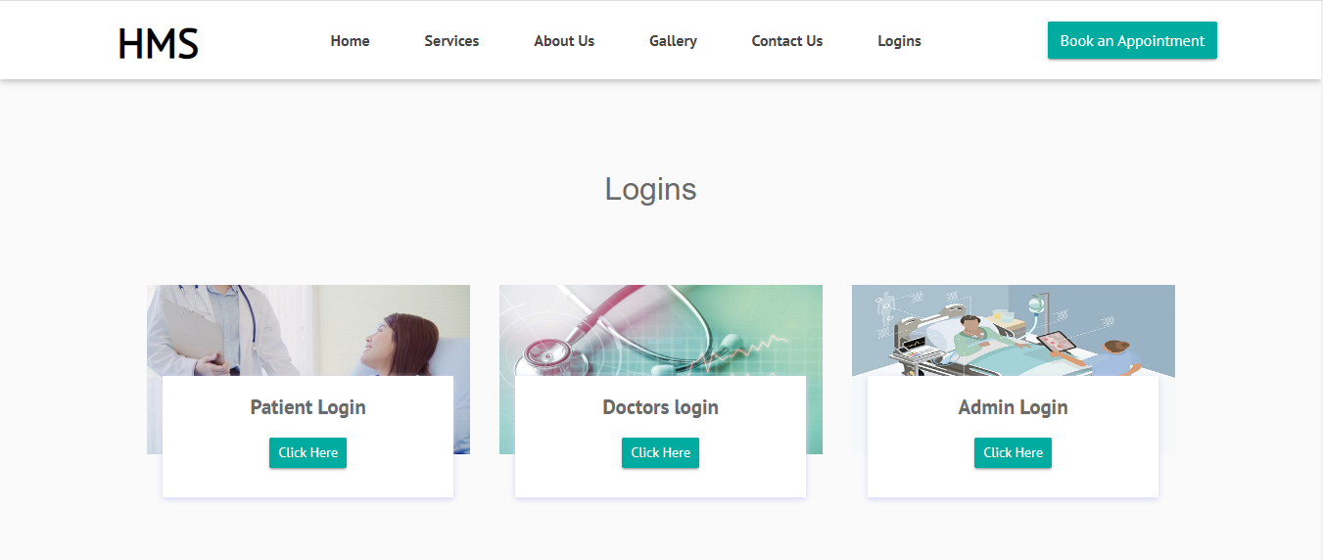

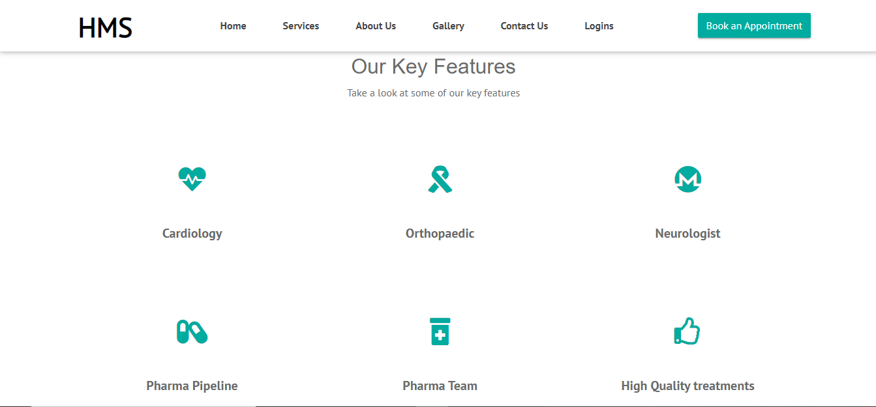

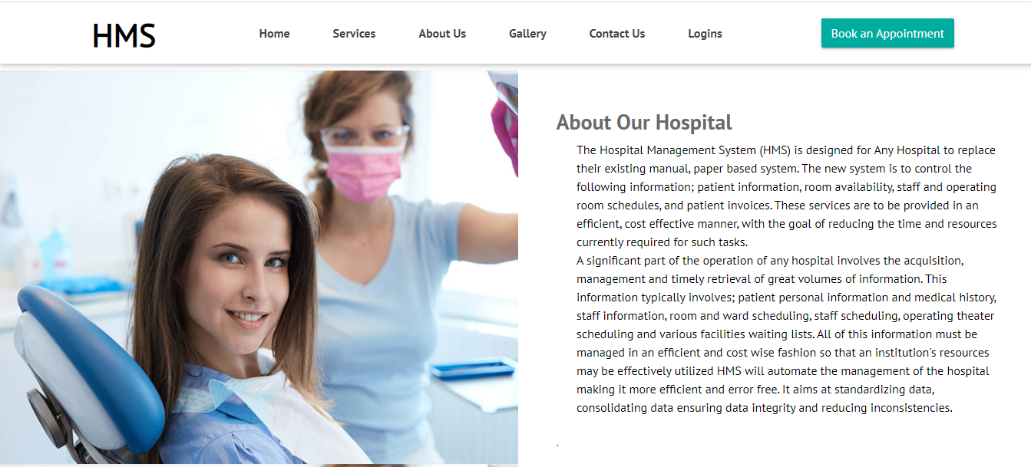



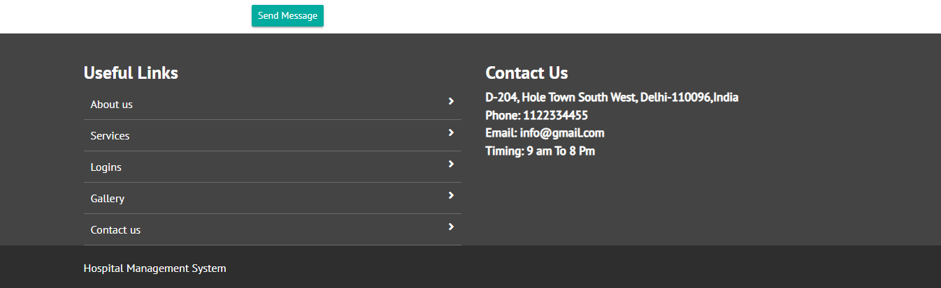

**Patient Login:**



**Doctor Login:**



**Admin Login:**



**Link of our project:**

3.112.45.105//dashboard/